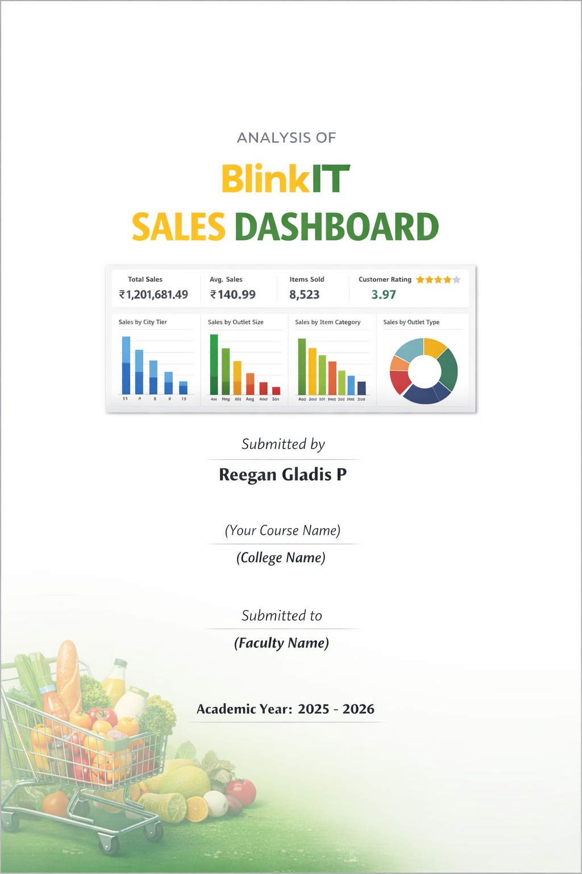
Introduction
Data Pre-processing and Business Analysis
Course
In today’s competitive market, data analysis plays a crucial role in decision-making. Dashboards help organizations visualize large amounts of data in a simple and meaningful way.
This report presents a detailed analysis of the BlinkIT Sales Dashboard, which provides insights into sales performance, customer ratings, outlet distribution, and product categories.
The dashboard helps management understand business trends and improve operational efficiency.

Objective of the Study:
The objectives of this report are:
- To analyze the overall sales performance of BlinkIT
- To study sales based on outlet size, type, and location
- To identify high-performing product categories
- To evaluate customer satisfaction using ratings
- To understand business insights through data visualization

Data Description:
The dataset used in this dashboard contains information related to:
- Sales amount
- Item categories
- Outlet size
- Outlet location
- Outlet type
- Customer ratings
- Number of items sold
This data is visualized using charts, graphs, and key performance indicators (KPIs).

Tools Used:
The following tools were used to create and analyze the dashboard:
- Microsoft Excel – Data cleaning and dashboard creation
- Charts and Pivot Tables – Data visualization
- Word Document – Report documentation

Key Performance Indicators (KPIs):
The dashboard highlights the following KPIs:
- Total Sales: ₹1,201,681.49
- Average Sales: ₹140.99
- Total Number of Items Sold: 8,523
- Average Customer Rating: 3.97
These indicators give a quick overview of business performance.

Sales Analysis:

Outlet Location Analysis:
Outlets are categorized into Tier 1, Tier 2, and Tier 3 cities.
- Tier 3 outlets contribute the highest sales
- Tier 2 outlets show moderate performance
- Tier 1 outlets contribute comparatively lower sales
This shows strong market potential in semi-urban and developing regions.

Outlet Size Analysis:
Outlets are divided into:
- Small
- Medium
- Large
Medium-sized outlets generate the highest sales, indicating optimal inventory and customer flow. Small outlets contribute the least.

Outlet Type Analysis:
The dashboard compares different outlet types:
- Supermarket Type1
- Supermarket Type2
- Grocery Stores
Supermarket Type1 performs best in terms of sales and visibility.

Product Category Analysis:
Sales are analyzed across various item types such as:
- Fruits and Vegetables
- Snack Foods
- Dairy Products
- Household Items
- Frozen Foods
Fruits & Vegetables and Snack Foods generate the highest sales, showing customer preference for daily essentials.

Customer Rating Analysis:
The average customer rating is 3.97, which indicates good customer satisfaction.
- Most outlets maintain ratings above 3.5
- This reflects consistent service quality and product availability

Insights and Findings:
• Tier 3 cities contribute maximum sales
• Medium-sized outlets are most profitable
• Daily -use items dominate sales
• Customer satisfaction levels are good
• Supermarket Type1 outlets perform better than others

Dashboard
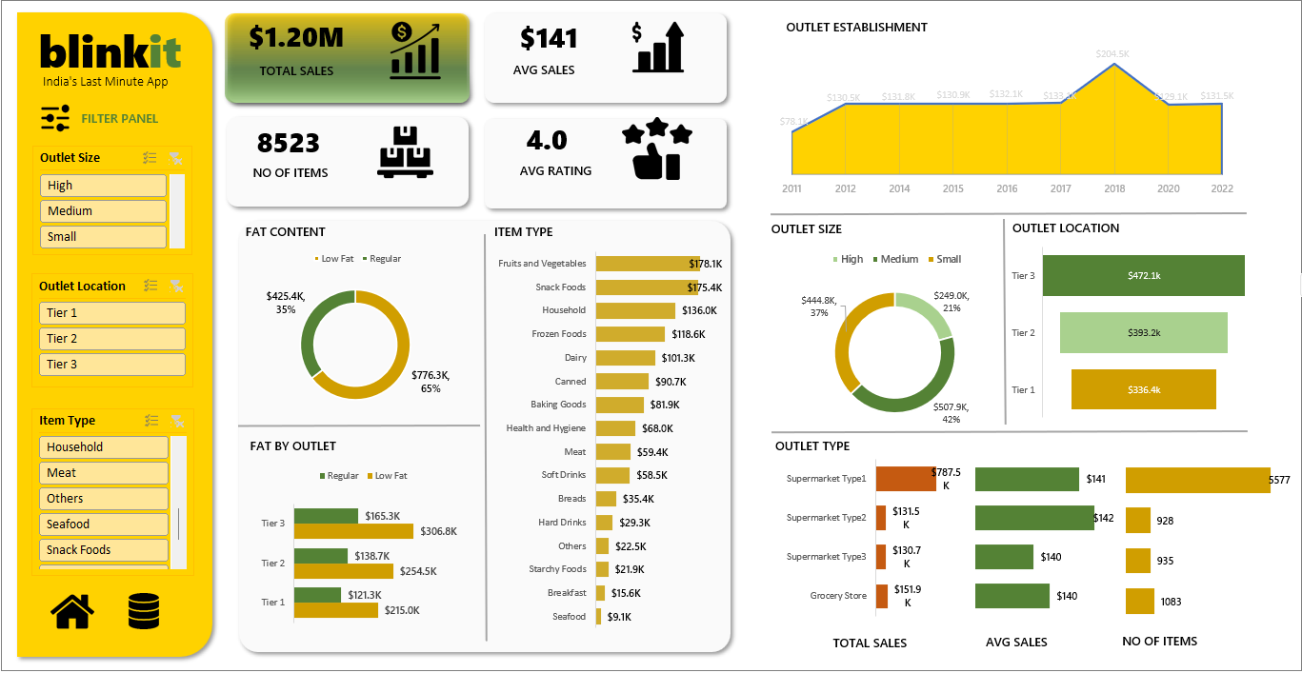

Conclusion

The BlinkIT Sales Dashboard provides a clear and effective visualization of sales performance and customer behavior. It helps identify strong business areas and opportunities for improvement.
This analysis can support decision-making in inventory planning, outlet expansion, and customer satisfaction strategies.

